Last Update: 5-07-2013
Instructions for use of Cuyahoga County GIS FTP Server
You will need to use an FTP client such as Filezilla, which is available as a free download here:
https://filezilla-project.org

1.) Set the FTP type to 'Active"
2.) Log in with the following credentials:
Host: ftp.gis.cuyahogacounty.us
Username: gisdata
Password: Gis-Cuyahoga (Upper Case G and C)

****************************************************
Note: There have been many requests for property characteristics such as land use, owner name, transfers, etc... This information can be sourced from the Fiscal Office FTP server. To map you will need to join with the parcel data via a join with the parcel identification number. Here is just some of the data that can be found there:
- Monthly transfers (.htm and .txt format)
- Top Tax Payers by municipalities (.xls format)
- Delinquent taxpayers (.xls format)
- Value statistics Average Sale Price statistics (.txt format)
- Industrial Reports (.pdf format)
- Database (all of the major real property warehouse tables in MSAccess) (.mdbx format)
- Comparable Sales (.xls format)
- Parcel Listings (.xls format)
The address is:
ftp://ftp.fiscalofficer.cuyahogacounty.us
Use the following credentials:
User: auditorreports
Pass: Access2012

DO NOT use Filezilla as is required for the GIS FTP server. We've had reports of people having trouble accessing the site from Internet Explorer. We recommend Firefox, which can be downloaded from firefox.com
******* For help with this data please contact the Fiscal Office directly at: publicrequest@cuyahogacounty.us

CONNECTING AND DOWNLOADING GIS DATA FROM CUYAHOGA COUNTY FTP SITE.

YOU MUST USE A FTP CLIENT.WE DON’T SUPPORT BROWSER BASED FTP DOWNLOADING.

- Download and install an ftp client. We recommend filezillafor its simplicity.
- Once installed, open the application (filezilla). You should see a window similar to the one pictured below.
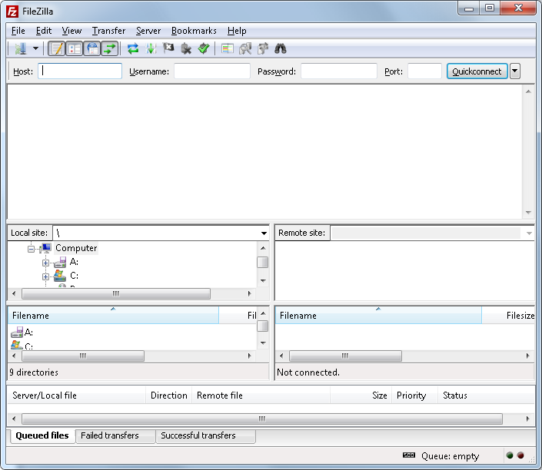

- Go to FILE, open SITE MANAGER, and click on NEW SITE. Enter ftp.gis.cuyahogacounty.us under HOST, USERNAME= gisdataPASSWORD=Gis-Cuyahoga as shown below. Leave everything else as is.
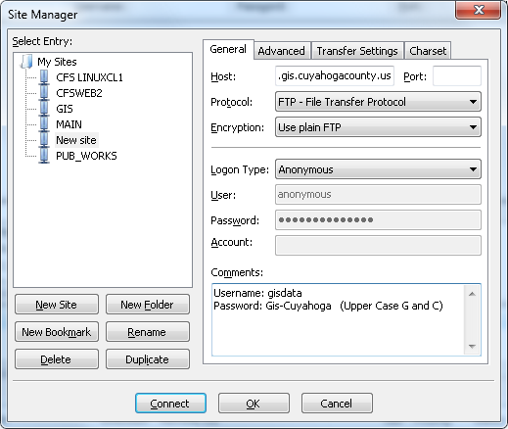

- Once you have entered all the required info such as host, username and password, and then click on Connect. You should now be looking at a screen similar to the one below

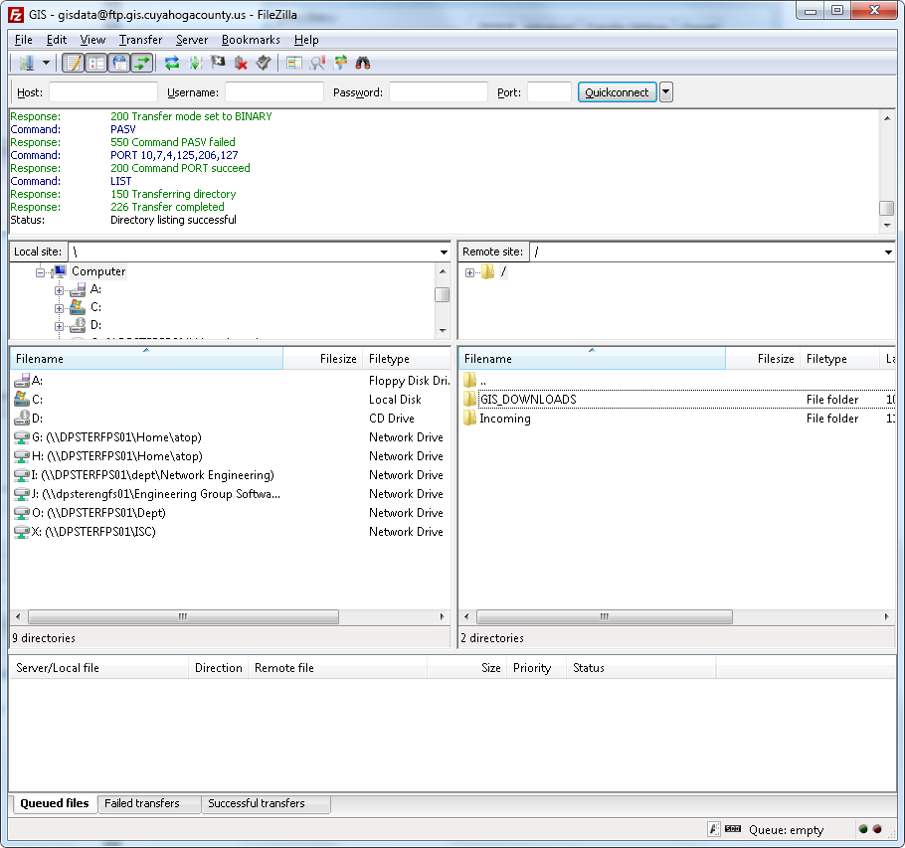

- The LEFT site is your local COMPUTER and the RIGHT side is the remote server containing the GIS data.
- Right click on any folder from the remote server, and select DOWNLOAD to copy the files to your computer.

Should you encounter any issues, please send an email to SUPPORT CENTER. (ISC_SUPPORT_CENTER@cuyahogacounty.us)

Data available for download as of the date shown above:
Data | File Name | Format
Airports | AIRFIELD.zip | Shapefile
Bridges | BRIDGE.zip | Shapefile
Large Building Footprints | BUILDING_2006.zip | Shapefile
County | COUNTY.zip | Shapefile
Address Points | CUY_ADDRESS_POINTS.zip | Shapefile
Street Centerlines | CUY_STREETS.zip | Shapefile
Tax Map Easements | EASEMENT.zip | Shapefile
Hydrography (East Half of County) | HYDRO_EAST.zip | ESRI Personal Geodatabase
Hydrography (West Half of County) | HYDRO_WEST.zip | ESRI Personal Geodatabase
Tax Map Map Book Grid (reference file) | MAPBOOKGRID.zip | Shapefile
Cities | MUNICIPALITY.zip | Shapefile
Aerial Photography Tile Index | ORTHOINDEX2007.zip | Shapefile
Tax Map Point Parcels (Condominiums, etc...) | POINTPARCEL.zip | Shapefile
Tax Map Polygon Parcels (Shapes only) | AREAPARCEL.zip | Shapefile
Railroads | RAILROAD.zip | Shapefile
Tax Map Right of Ways | RIGHTOFWAY.zip | Shapefile
School Districts | SCHOOLDISTRICT.zip | Shapefile
Tax Map Subdivisions | SUBDIVISION.zip | Shapefile
2011 Aerial Photography Uncompressed |  | Tiff
2011 Aerial Photography Compressed |  | G3 MrSID
2006 2-Foot Contours |  | ESRI Personal Geodatabase
2006 2-Foot Contours | ShapefilesEast.7z and "West.7z | Shapefile
2006 LiDAR (Raw) |  | .LAS
2006 LiDAR (Classified) |  | .XYZ
2006 DTM |  | ESRI Personal Geodatabase
County Council Districts | COUNCIL_DISTRICT_2012 | Shapefile
2013 Aerial Photography Compressed |  | G3 MrSID
2013 Aerial Photography Uncompressed |  | Tiff
Note: There is a reference file (ContourIndex.mdb and ContourIndex.pdf) in the Contours directory. This reference file is for the contours, hydrography, LiDAR, and DTM files.

Questions Contact:
John Kable
GIS Planning and Development Manager
jkable@cuyahogacounty.us
216-443-8043

